SLA Splitter Shiny app
An app written in R and Shiny to take data previously formatted for a local authority SLA and split it into appropriate worksheets. The app replicates the functionality in the Commercial Restrictions Macro when the Split sheets for SLAs macro is run
There are options:
- To specify the Excel spreadsheet containing the data
- Which local authority the data is for
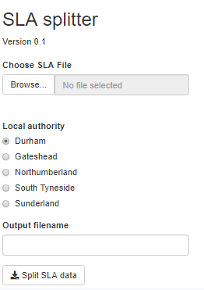

Output
- An Excel spreadsheet containing the original data and additional worksheets for specific species and taxon groups depending on the LA selected.

Running the app
The source files for SLAs are typically too big to host the Shiny app online. Therefore it needs to be run within RStudio. See the document “R Shiny and Github” for notes on how to do this

Code overview
The code makes extensive use of the ERIC_Data_Proc data processing library developed in R.
There is configuration setup indicating for each local authority:
- A mapping between worksheet names and selection criteria for the data to include
- The data columns to output
The app code does the following:
- Get input parameters
- Read the data from the input file
- Format the three date fields
- Output all the data to the source sheet within the Excel workbook
- Remove data with vague grid references (four figure references or worse) from the working data
- Loop through the mapping of worksheet names and selection criteria:
  - Create a sheet with the appropriate name
  - Output data meeting the criteria to the sheet
  - If required by the authority append the data to an “all data” sheet
- Save the Excel spreadsheet, asking the user for the name and location

Anne Donnelly – 20/07/22

